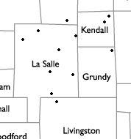

**Somonauk-**

**Leland-**

**Sandwich**

**Oswego-East**

**Oswego**

**Newark**

**Serena**

**Minooka**

**Ottawa**

**Seneca**

**Earlville**

**Mendota**

**Streator**

**Woodland**

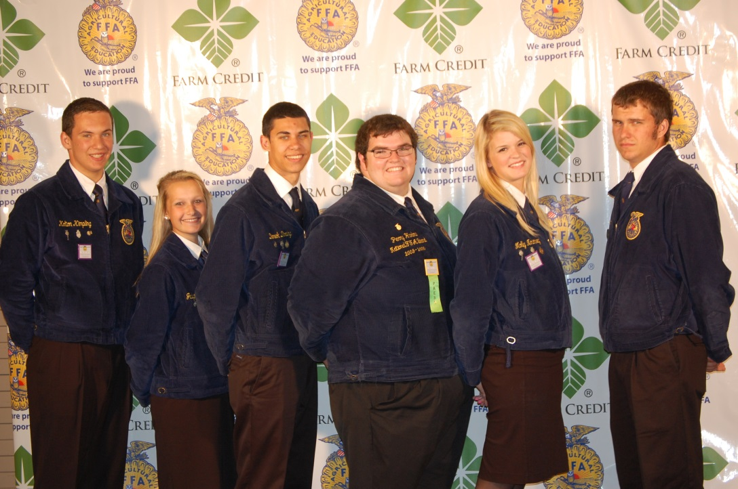

**2013-14 Section 7 Officer Team**

On May 3rd, 2013, the 2013-14 Section 7 Officer team was elected at the Seneca High School Land Lab. This year’s officers are as follow: President-Bryan Temple (Serena FFA), Vice-President-Molly Novotney (Seneca FFA), Reporter-Perry Harlow (Seneca FFA), Secretary-Derek Doeing (Newark FFA), Treasurer-Jalyne Herren (S-L-S FFA), and Sentinel-Kolton Kimpling (Woodland FFA). The officer team is very excited to serve the Section 7 FFA members this year and can’t wait to engage with the new and returning FFA members!

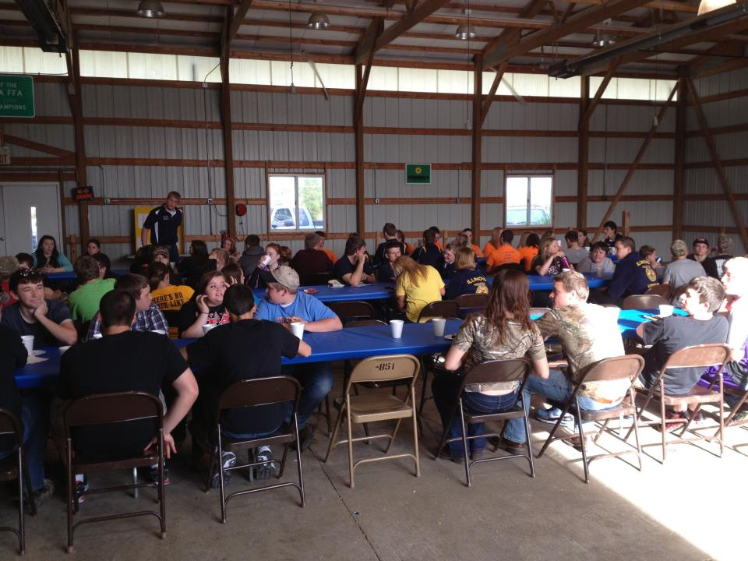

Do you love taking pictures? If so there are two photography competitions for you! The first one is the *Cream of the Crop Photo Contest*. As part of the Ag Invest program, Illinois State Treasurer Dan Rutherford is excited to announce the launch of the Cream of the Crop Photo Contest. They invite students from across the state, ages 8-18, to submit their most innovative, scenic snapshot that depicts their vision of agriculture in our state. For more information, please visit [www.trasurer.il.gov](http://www.trasurer.il.gov). The second contest is the 1st Farm Credit Services. They are calling all photographers to send in their pictures depicting agriculture and rural life. If your photo is selected, it will be submitted into the annual 1st Farm Credit Services calendar! For more information, please visit [www.1stfarmcredit.com](http://www.1stfarmcredit.com).

Attention all Photographers!

* **Games**
* **Officer Elections**
* **Memories**

**Section 7 Shindig**

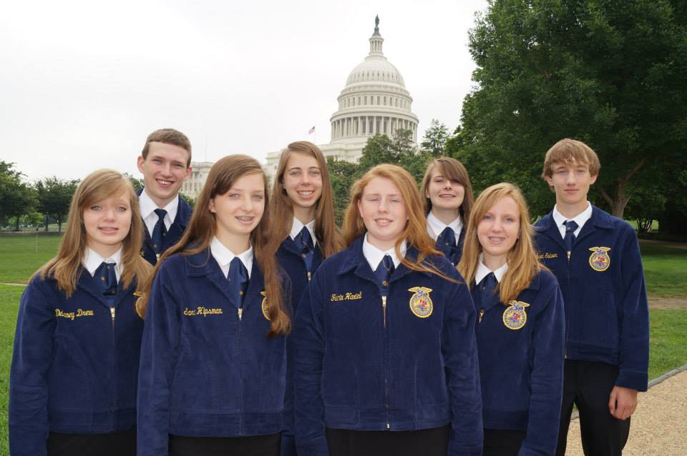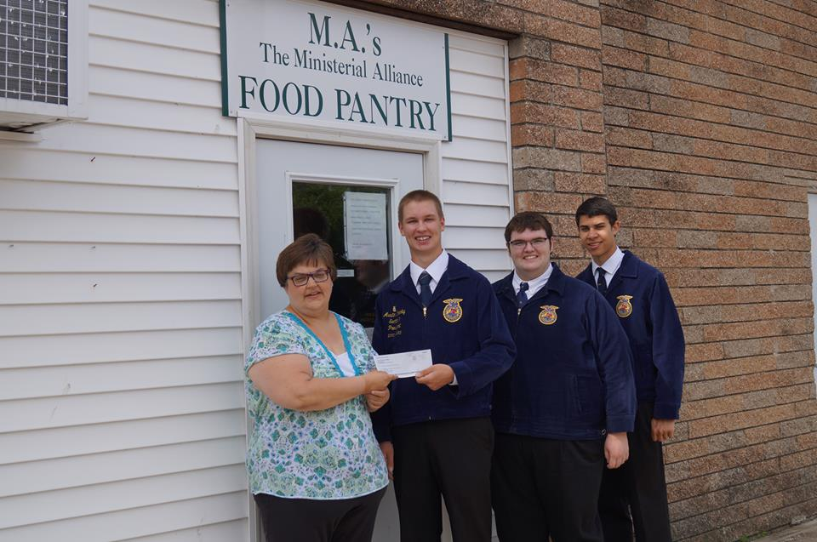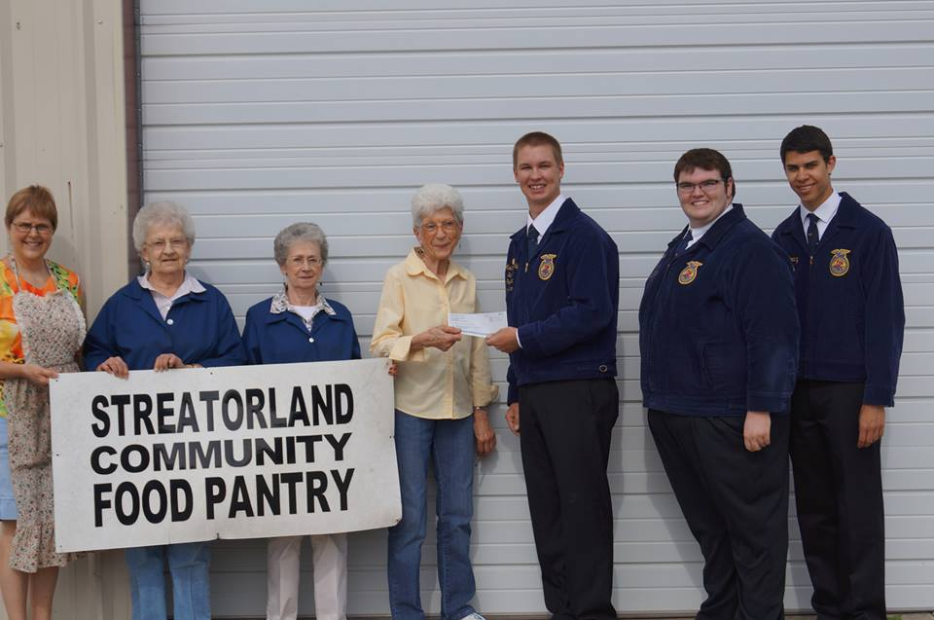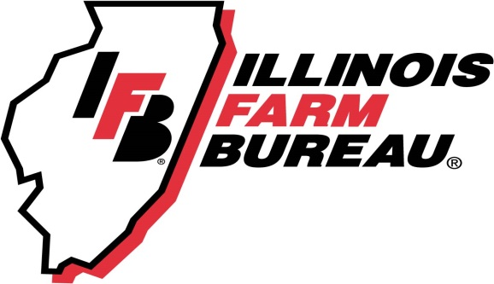

8 lucky Section 7 FFA members had the opportunity to tour our nation’s capital from June 22nd to June 30th. On this trip they had the opportunity to visit Gettysburg, Air and Space Museum, Mt. Vernon, Holocaust Museum, Int’l Spy Museum, Ford’s Theatre, American History Museum, tour the Capitol, Arlington National Cemetery and Iwo Jima. This trip is sponsored by the Illinois Farm Bureau Youth Education Committee. The committee consists of Illinois FFA State staff, Illinois FFA Major State Officers, 4-H Representatives, Prairie Farms, Growmark, IAA Credit Service, County Financial, and members of Illinois Farm Bureau. The students qualified for this trip because their school either won the Section Heritage or Cooperative application or their school was in the 5 in the state for Heritage or Coop.

**ILFB Heritage & Cooperative trip to Washington, D.C.**

On an early May morning, some of the Section 7 officer team drove to Streator and Flanagan to present a check to the local food pantries. The check contributions to these food pantries were made possible from the Penny Wars at the ILFB Youth Conference. At Youth Conference this past year, the Youth Conference had a contest for whichever FFA section brought in the most pennies they would be able to donate that money to any organization in their community. Whatever section won, they would also take all of the other pennies from the other sections and add it to the donation. At the conference, the FFA members raised $1257.22! The section 7 officer team decided to let the school that brought in the most pennies for the contest would donate the money to the organization of their choice. The Woodland FFA chapter decided to donate the Penny War contribution to the Streatorland Community Food Pantry and The Ministerial Alliance Food Pantry.

**ILFB Youth Conference Penny Wars**

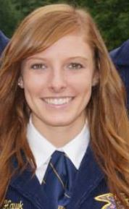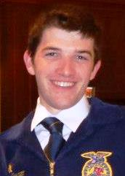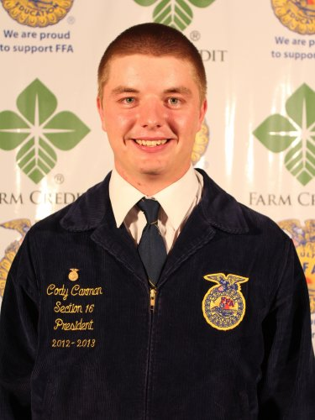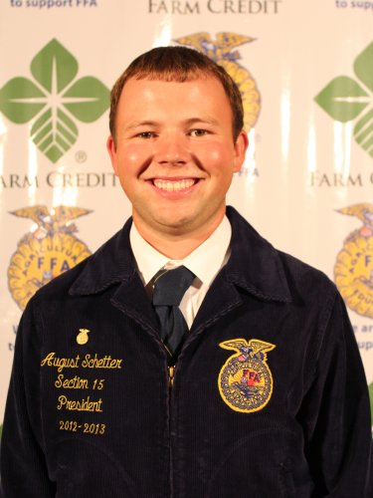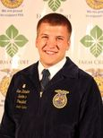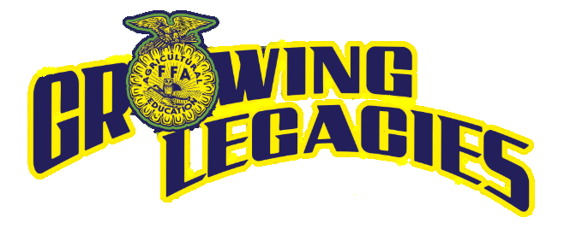

State FFA Officer Team

**Treasurer**: Joe Heavner, 19, of Valmeyer (Monroe County) and the Valmeyer FFA Chapter. He is the son of Howard and Ellen Heavner. Joe is a 2012 graduate of Valmeyer High School and studied at Southwestern Illinois College this past year working towards an associate’s degree in science.

**Secretary**: Cody Carman, 18, of Sullivan (Moultrie County) and the Sullivan FFA Chapter. He is the son of Keith and Monica Carman. Cody is a 2013 graduate of Sullivan High School and plans to study agricultural education at Southern Illinois University Carbondale.

**Reporter**: August Schetter, 18, of Brighton (Jersey County) and the Southwestern FFA Chapter. He is the son of Dan and Mary Jo Schetter. August is a 2013 graduate of Southwestern High School and plans to study crop sciences at the University of Illinois at Urbana-Champaign.

**President**: Sam Detwiler, 19, of Flanagan (Livingston County) and the Flanagan-Cornell FFA Chapter. He is the son of John and Jane Detwiler. Sam is a 2012 graduate of Flanagan-Cornell High School and studied at Heartland Community College this past year working towards an associate’s degree. Sam plans to transfer to a four-year university and earn an agriculture degree.

**Vice President**: Rachel Hawk, 18, of Aledo (Mercer County) and the Mercer County FFA Chapter. She is the daughter of Mark and Shelly Hawk. Rachel is a 2013 graduate of Mercer County High School and plans to study animal sciences at the University of Illinois at Urbana-Champaign.

**85th Illinois FFA State Convention**

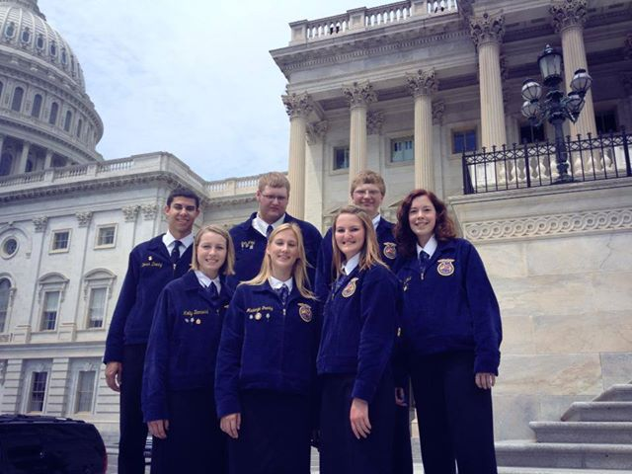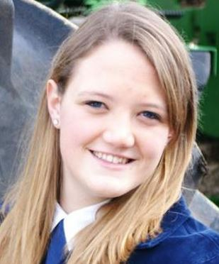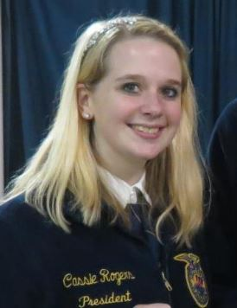

Derek Doing (Newark), Seth Wiley (Serena), Tyler Perkins (Newark), April Ohst (Mendota), Melanie Bennett (S-L-S), Mackenzie Granby (Seneca), and Molly Bernard (Newark) spent a week in Washington, D.C. to attend the Washington Leadership Conference. This is a weeklong conference that helps FFA members learn what their purpose is and also to create a Live to Serve Project. FFA members learn what it means to be an authentic leader, how to connect with their community, and how to leave a “ripple” on someone. Many of the members had a great time there and they can’t wait to share their experience with other FFA members.

**Illinois Bus to WLC**

Top 10 Chapter Reporters:

Cody Wrobel (S-L-S)

Top 10 Chapter President:

Cassie Rogers (S-L-S FFA)

**Oustanding Chapter Reporter**

Bronze Rating:

Crystal Dau (Serena)

**Outstanding Chapter Presidents**

2012-13 Section 7 President Austin Granby was selected as a winner of the Top 10 Section Presidents award. From this award, he was invited to the Premier 20 leadership conference where he learned about living with disabilities, communication skills, and packed meals for the Midwest Food Bank.

Granby awarded Top 10 Section President Award

Silver Rating: (From L to R)

Britney Hahn (Mendota)

Molly Novotney (Seneca)

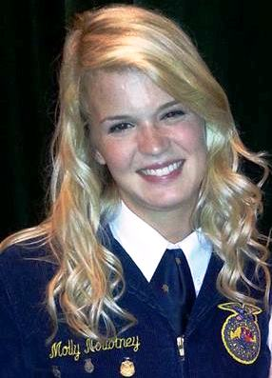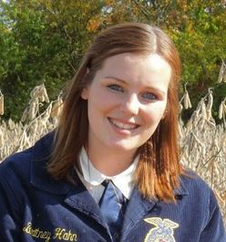

**FFA Communications Summit 2013**

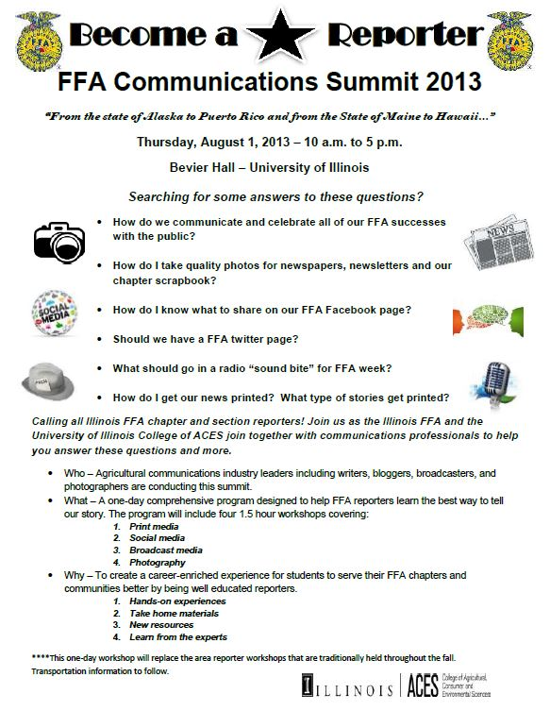

C:\Users\Owner\AppData\Local\Microsoft\Windows\Temporary Internet Files\Content.IE5\S3Y321DS\MC900339740[1].wmf

**We are on the Web!**

Chapter Reporters: I encourage you to send me your articles on what is happening in your chapter. I will make a page in this newsletter for the Chapter Chatter. This is basically a place for your chapters to submit their news and you can also see what other chapters are doing to get some ideas for your chapter. This will be a benefit for you to have a place to submit news. I will also place your articles on our webpage under the “Section Chitchat” tab.

**Attention all Chapter Reporters!**

**Contact Us!**

Illinois Section 7 FFA is on the web! We have a website created for your use to read articles, see upcoming events, and get to know your officers. As your chapter reporter, I try to keep this site updated often and post articles of interest and pictures. My main goal in doing this is to keep everyone updated with what is going on in Section 7. Find us at ilsection7ffa.weebly.com.

We also have a Facebook & Twitter page. I encourage all of your current chapter members along with alumni and past members to like us on Facebook and follow us on Twitter. I post all of the photos from events there along with the articles on the events.

Bryan Temple ~ President

* 815/830-9009
* mowingnshowing@yahoo.com

Molly Novotney ~ Vice-President

* 815/546-1156
* [molly.novotney@gmail.com](mailto:molly.novotney@gmail.com)

Perry Harlow ~ Reporter

* 815/343-0488
* [perryharlow@hotmail.com](mailto:perryharlow@hotmail.com)

Derek Doeing ~ Secretary

* 815/585-2530
* [doeing20@gmail.com](mailto:doeing20@gmail.com)

Jalyne Herren ~ Treasurer

* 630/391-0189
* softballbaba24.7@gmail.com

Kolton Kimpling ~ Sentinel

* 815/674-3093
* [koltonkimpling@gmail.com](mailto:koltonkimpling@gmail.com)



ilsection7ffa.weebly.com

https://twitter.com/Section7FFA

www.facebook.com/section7ffa



ilsection7FFA@gmail.com

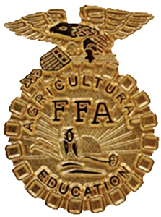

Convention is everyone’s favorite part of year. This is the time of year where members can meet up with other FFA members that they went to FFA camp with, the Heritage and Cooperative trip, or Washington Leadership Conference. This is also the same time of year when members are awarded for their hard work and dedication to their record books as they are award a proficiency award winner, their State FFA Degree, or winning a Career Development Event.

But personally my favorite part of convention is listening to the Keynote address by the guest speakers, hear one of National FFA officers speeches, and the Retiring Addresses from the Major State FFA officer team. Even though the speeches don’t last longer than 20 minutes, I believe that the speeches are the meat and bones of the convention. This is where the true message of convention is conveyed. If someone listens very closely to the speeches, there is always a secret message or a life lessons in each and every one them. One example of this is Tyson Schulte’s retiring address. He talked about how much he loved baseball and he was going to play baseball all throughout his school years. His ball career was cut short when a baseball hit him in the eye and almost made him blind because of the injuries. That injury didn’t stop him. Even though he couldn’t play his favorite sport anymore, he became more active with the FFA and showing swine. The life lesson here is to never give up when something crosses your path. Personally, if that baseball didn’t hit him in the eye, I don’t think he would be up there giving a retiring address. Like my grandmother always says, when one door closes there is always one very close that will open.

I want you, the members, to do me a favor the next time you hear someone give a speech. I really want you to pay attention to what they are saying. I want you to hear those life lessons and try to connect them to your life. Please just listen.

Yours truly in Blue & Gold,

Perry Harlow

Section 7 Reporter

**Just Listen…**

**State Degree Winners**

Congratulation to all of the FFA members that were awarded their State FFA Degree at State Convention!

**Mendota**- Ryan Althaus, Greg Bator, Evan Peach

**Newark**- Molly Bernard, Derek Doeing, Deanna Drew, Tyler Wiesbrook

**Seneca**-Alex Autry, Brian Bergeson, Loren Fisk, Colton Jackson, Molly Novotney, Jacob Theissen

**Serena**-Bryan Temple

**Somonauk**-Leland-Sandwich-Cassie Rogers, Brody Zmolek

**Woodland**- Auston Mehalic, Tommy North, Sara Spaniol, Matt Wilson